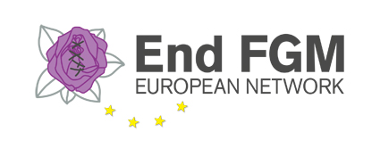
ABSTRACT SUBMISSION FORM
End FGM European Network Building Bridges seminar, 30th May 2017

Name of the proponent
Organisation
Country
Email
Phone (with int. code)

Title of the proposal

Description of the project/activity/policy/research (max 300 words)

Outline of the session (max 150 words) (this text will be published)

Goal of your session (what will participants take home with them in terms of knowledge, skills, inspiration?) max 100 words.

Format
Presentation (speech and/or PowerPoint)
Debating session (plenary debate with participant using interactive voting methods or debate with expert panel and participants)
Working session (using various working methods to achieve a concrete result/product)
Short training or instruction session
Educative games or simulation (role playing, quiz, etc.))
Short movie or documentary
Case-based session (discussing concrete cases or stories)
Other, please specify

Presenter/chair/moderator (name and affiliation/expertise)

Contributors (names and affiliations/expertise)

Duration of the session (max. 15 min. for traditional presentations and 1,5 hours for interactive sessions)

Requirements
laptop
beamer
Wi-Fi
sound system
flip-over
other, please specify

Other remarks or suggestions

Procedure
Proposals can be submitted (in English) to info@endfgm.eu by sending the completed form by the 5th of May.

The Programme Committee will review the proposals using the following criteria
- Conformity with the overall theme of the seminar
- Interactivity and creativity of the proposed format or working method
- Variety in topics and format proposed.

All submitters/contributors will be informed after the selection procedure is completed. We aim to inform all submitters/contributors before the 10th of May 2017.

If you have any questions, please contact Liuska Sanna at lsanna@endfgm.eu

